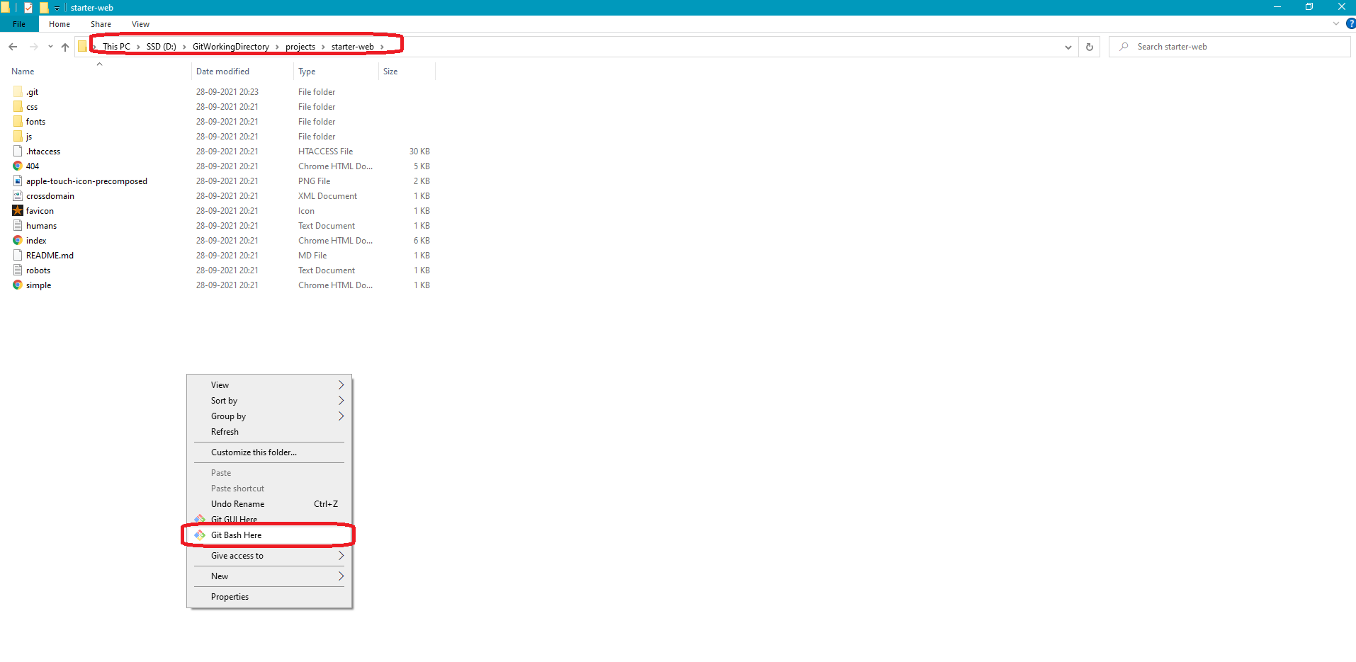

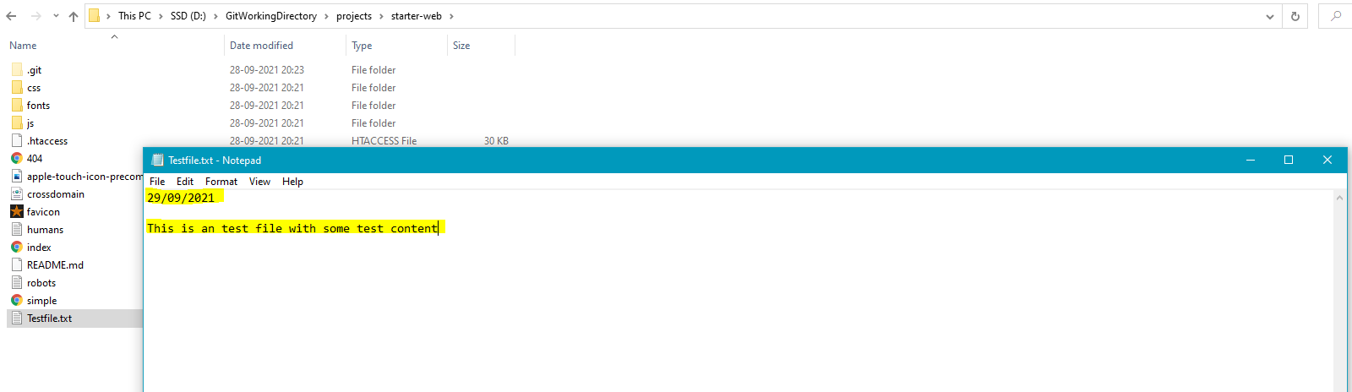

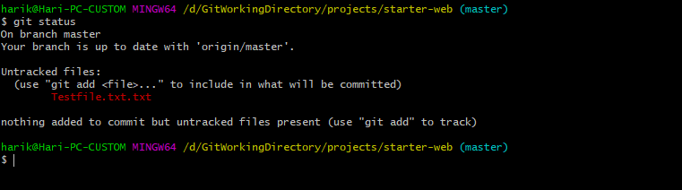

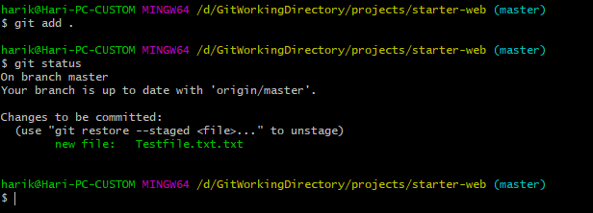

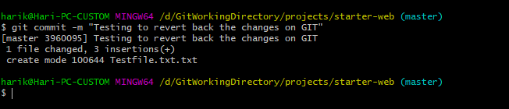

Remember before pushing any changes from Git, always pull the changes from the remote repository.

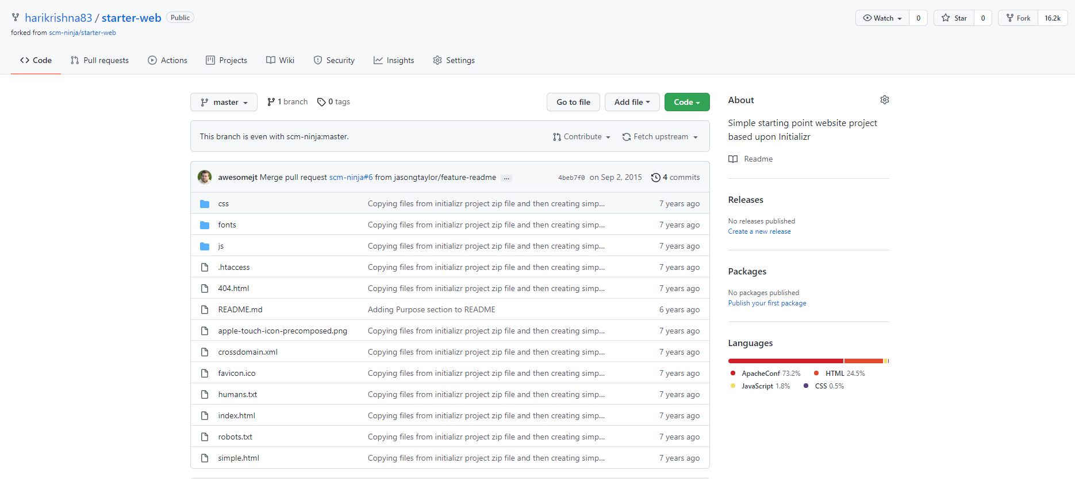

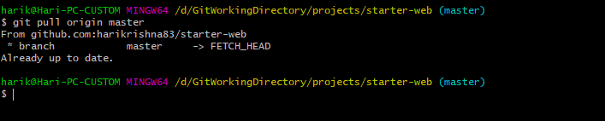

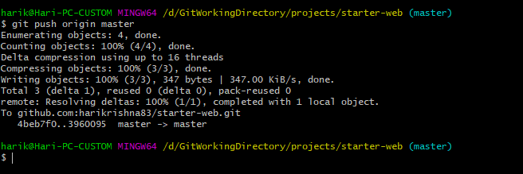

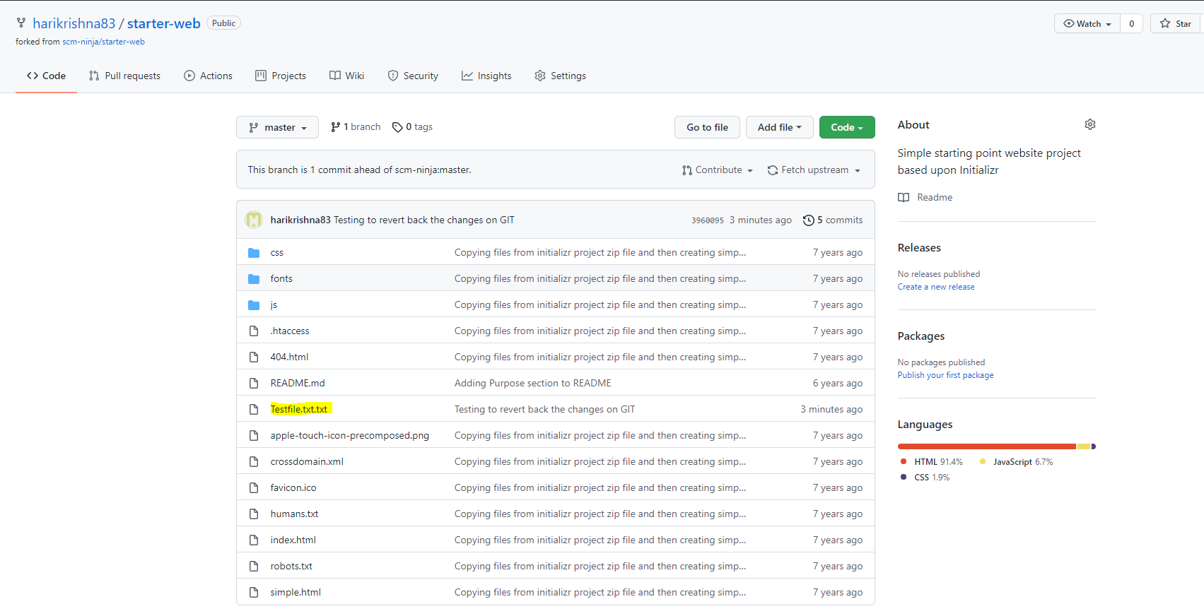

Now add some of additional dummy content to the file and see how to back out the changes.

Added some of the content on that file as shown below and moving to staging area.

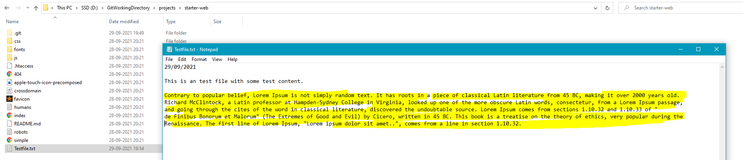

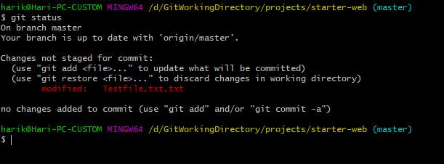

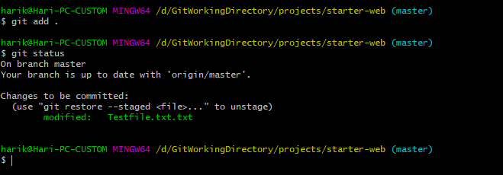

After moving the file to staging area from my working area I realized that I made a mistake on that file and want to revert it back.

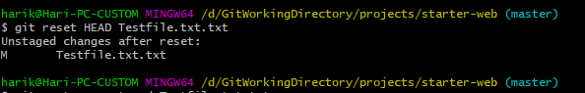

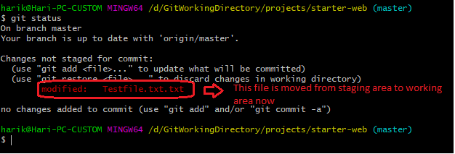

But if you open the file, still the modified content will be there.

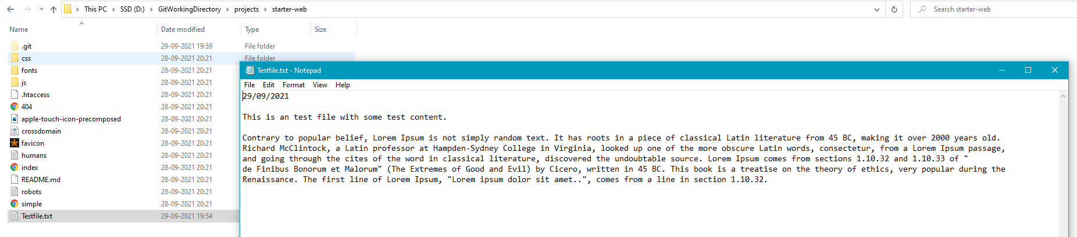

If you want to remove the content also from the file, use the below command.

